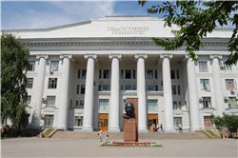 | 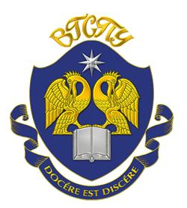 | 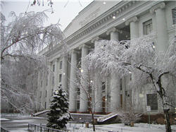
Volgograd State Socio-Pedagogical University (VSSPU) is a leading center of education, research, culture and the arts in the South of Russia. The University has more than 10500 students, including international students from about 20 countries of the world, highly professional faculty and staff, well-known research schools, and developed infrastructure.
VSSPU International Partners
Volgograd State Socio-Pedagogical University has well-established scientific and academic connections with universities and colleges in the United States of America, Germany, Austria, the Netherlands, France, People's Republic of China, Serbia, the Czech Republic, Ukraine, Kazakhstan, etc.
In recent years new projects supported by the Embassies of China, Austria, France, Germany and USA have emerged.
International cooperation includes partner-degree programs, faculty and student academic mobility, academic exchanges, international conferences and seminars, internships, research and publications as well as videoconferencing and distance learning.
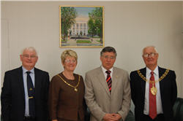 | 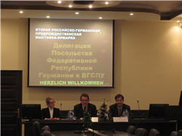
VSSPU International Centers
Volgograd State Socio-Pedagogical University has a number of International centers that promote intercultural communication and research through a variety of activities including international conferences, seminars, videoconferences and lectures, study-abroad programs, faculty and student exchanges, multi-cultural projects and joint publications.
VSSPU International Centers are:
- Center of the German Language;
- Center of American Studies;
- Educational Center "World Languages and Cultures";
- Character Development Center;
- Confucius Institute;
- UNESCO affiliate "Preservation of the Biodiversity of the Lower Volga Region";
- International Center of Childhood and Education;
- Center of the Russian Language Testing;
- Resource Center of the French Language;
- Center of the Austrian Culture;
- Center of the Russian-Chinese Intercultural Research.
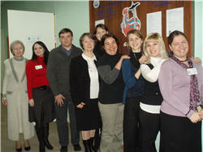 | 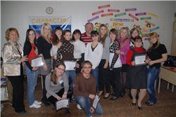
VSSPU International Students
Volgograd State Socio-Pedagogical University has a 40-year history of teaching international students from different countries of the world. More than 7000 international students have received their bachelor's and master's diplomas here, 15 internationals have become Doctors of Philology or Pedagogy.
International students are an essential part of the University life participating in international conferences and seminars, carrying out research and sharing their native culture with the Russian students and faculty. Talented and goal-oriented as they are, VSSPU international students become winners of all-Russia and regional linguistic competitions, winners and laureates of the art exhibitions and international music festivals and concerts.
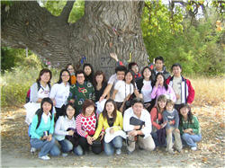 | 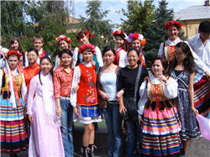
Contact Information:
Address: 27 prospekt Lenina, Volgograd, 400131
Еmail: mo@vspu.ru; oms@vspu.ru
Website: www.vspu.ru
Tel / fax: (8442) 602846

